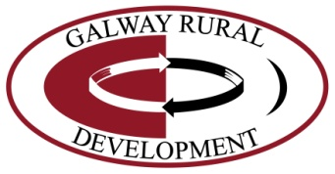
Rural Development Programme 2014 – 2020 LEADER
Expression of Interest (EOI) Form
NOTE: This Expression of Interest (EOI) form must be completed as a pre-cursor to an application proper for funding under the Rural Development Programme 2014 – 2020 (LEADER).
Failure to complete this form completely will result in a delay in dealing with your Expression of Interest and any further processing of any subsequent application arising therefrom
for funding under RDP 2014-2020.

Step 1: Expression of Interest (EOI)
This Expression of Interest Form is the first step of a two-step LEADER application process. Please note this is an Expression of Interest form (EOI) and NOT an Application form. The EOI must be completed in full (all fields are mandatory) and failure to do so will result in a delay in processing your EOI. Fully completed EOIs will be assessed for eligibility under the Rural Development (LEADER) Programme 2014-2020, and approved by the Board of Galway Rural Development.
- A hardcopy of this form can be obtained from Galway Rural Development.
- This form can be downloaded or printed from www.grd.ie and posted to Galway Rural Development Co. Ltd or emailed to leader@grd.ie with any additional information you feel may be of relevance to your EOI.
- Galway Rural Development Co. Ltd will acknowledge receipt of your EOI.
- A LEADER Development Officer from Galway Rural Development Co. Ltd will contact you when your Expression of Interest Form has been reviewed.
- Following eligibility assessment of your EOI, you will be informed of the outcome.
- If you require assistance in completing this form please use the contact details below.

If your project is eligible in principle, you may be invited to make a formal application for funding.

Step 2: Full Application
You will be invited to engage and participate in the Galway Rural Development LEADER application support activities, before completing and returning your Application Form to Galway Rural Development, in line with the requirements and timeframes as set out in each particular LEADER Funding Call, and the LEADER Operational Rules.
Contact Information
Galway Rural Development Co. Ltd, Mellows Campus, Athenry, Co. Galway.
Tel 091 844335 or email: leader@grd.ie
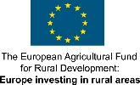
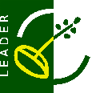
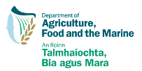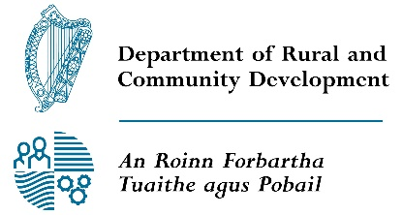
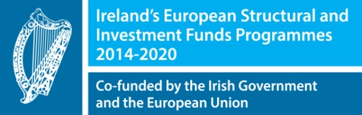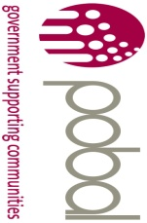

Rural Development Programme (Leader) 2014 – 2020
Expression of Interest (EOI) Form
GENERAL INFORMATION
All Fields are mandatory and must be completed.
Your Local Action Group (LAG) name: |  | Galway Rural Development Co. Ltd, Mellows Campus, Athenry, Co. Galway
Project Name / Title:

Promoter’s / Community Groups Name:

Promoters Lead / Main Contact Name:

Promoters Main Telephone (Mobile if possible) No.:
Promoters E-mail Address:
Promoter’s Address: |  | Eircode: _____________________
Promoter Type:  [Individual, Community Group, Organisation, Other]. |  | Classification of Promoter: Cross appropriate box and include copies of supporting governing documents with this application.  Sole Trader Community Council  Farmer(Herd No. _________________) Trust  Formalised Community/Voluntary group Partnership  Companies Limited by Guarantee Limited Company  Designated Activity Company limited by shares Private Individual  Registered Charity  Cooperative society registered under the Industrial & Provident Societies Act  Other _______________________________
Has Promoter / Community Group received Leader funding in the last 7 years?  Please tick one |  | YES NO  If Yes, Please provide the following:  Purpose of grant aid: ____________________________________________________  Amount: €______________  Date of approval: ______________________
PROJECT INFORMATION
Project Title and Address :

Project located in Gaeltacht area : |  |  | YES NO
LEADER Funding Amount Required |  |  | €_____________________
Projects Other Funding sources: |  |  | (Please include any funding application outcomes pending from other sources)  - Cash / savings - Bank Loan(s)  - Local Authority - National Lottery  - Fáilte Ireland - Heritage Council  - Local Enterprise Office - Private matching from communities  - Other ____________________________________  Please also specify the amount________________________________________
Please give a brief description of the proposed project below (min 50 – max 500 words)

Please identify and itemise what elements of the project you are seeking grant aid for? (e.g. building, equipment, professional fees, marketing, training, Analysis and Development)
 | Description | Approx Cost € (ex VAT)
Item 1
Item 2
Item 3
Item 4
Total

Project Time Frame: | Proposed start date: |  |  |  | Proposed completion date:
Is a site/ building required for this project? |  |  |  | Yes No In Place
If so, is the site/ building in your ownership? |  |  |  | Yes No In Place
Is a Lease Required? (min 7 years) |  |  |  | Yes No In Place
Is Planning Permission Required? |  |  |  | Yes No In Place

DATA PROTECTION ACT CONSENT FORM

Galway Rural Development Co. Ltd is responsible for delivering the Rural Development Programme LEADER 2014 – 2020. We are required to collect information on individuals and community groups whom we assist.
As soon as you contact Galway Rural Development Co. Ltd, a record is created in your name for the information you provide. The information will be stored by us where relevant in paper/electronic form. Information that we then collect including information that you give us is added to the record.

You have the right, given by the Data Protection Act of 1988 and 2003 to a copy of your information at any time. We charge a fee of €6.35 for each request.
You should address your request to: Galway Rural Development Co. Ltd, Mellows Campus, Athenry, Co. Galway.
The information we record is used only for the following purposes:
- Processing of applications
- Auditing of applications (Article 48 check)
- Compiling statistical information to help us plan and improve our services
- Analysing information about applicants for other bodies such as various Government Departments
- Producing our own statistics for publication
- Publication of promoter and project details (including photography) for publicity and promotional purposes.

Personal information about you will be disclosed only in accordance with LAG registration under the Data Protection Act. The purpose for which we hold information and the people to whom we may disclose it are listed in the Register of Data Controllers. This is a public register kept by the Office of the Data Commissioner at the Irish Life Building, Talbot Street, Dublin 1. (Phone 01- 874 8544), and you may inspect it free of charge.
To give you an example of disclosure: Galway Rural Development Co. Ltd is required to give promoters names and certain other personal data to Rural Development Division in the Department of Agriculture, Food and Rural Development. The Department in turn observes strict rules of disclosure that are registered with the Office of the Data Protection Commissioner. Other information supplied and collected may also be disclosed to people and bodies from time to time. On request you can receive a list of disclosures.
Signed for and on behalf of the Promoter / Group:

I have read and understand the above statement on the Data Protection Act and give consent to Galway Rural Development Co. Ltd for the use and disclosure of data and information as outlined above.

I/ We confirm that the details supplied are true and correct to the best of my/our knowledge

Print Name: ________________________________

Signature: ________________________________

Witness: ________________________________

Date: _______/______________/_________

Part or all of the information you provide will be held on computer and hard copy format. This information will be used for the administration of Expression of Interests and producing monitoring returns. LAG’s may share information with each other and government departments/agencies to enable them to prevent fraudulent applications or for detecting crime and to co-ordinate processing of complementary applications. It may also be subject to meeting obligations under the Freedom of Information Act as amended. This policy does not affect your rights and your information will be held as prescribed under the Data Protection Acts 1988 and 2003.

For Office Use Only:

EOI Ref ID
(Generated from RDP IT System)
Call Type | Rolling Time limited  If time limited (please state Call Name)  _________________________________________________________
Programme Theme | Economic Development, Enterprise Development & Job Creation  Social Inclusion  Rural Environment
Programme Sub-theme | Rural Tourism  Enterprise Development  Rural Towns  Basic Services  Rural Youth  Protection & Sustainable Use of Water Resources  Protection & Improvement of Local Biodiversity  Development of Renewable Energy
Local Objective No:

Received by: (Signature)

Received by: (Print Name)

Date of Receipt

LAG Date Stamp

